10_IP Classes
Tags: #network

10_IP Classes

IP Address Classes
IP addresses are divided into network ID and host ID. The address class system defines how IP space is allocated.

Primary Address Classes
Class | Network ID | Host ID | First Bits (Binary) | First Octet (Decimal) | Hosts per Network
A | First octet | Last 3 octets | 0 | 0–127 | 16,777,216 (2²⁴)
B | First 2 octets | Last 2 octets | 10 | 128–191 | 65,536 (2¹⁶)
C | First 3 octets | Last octet | 110 | 192–223 | 256 (2⁸)
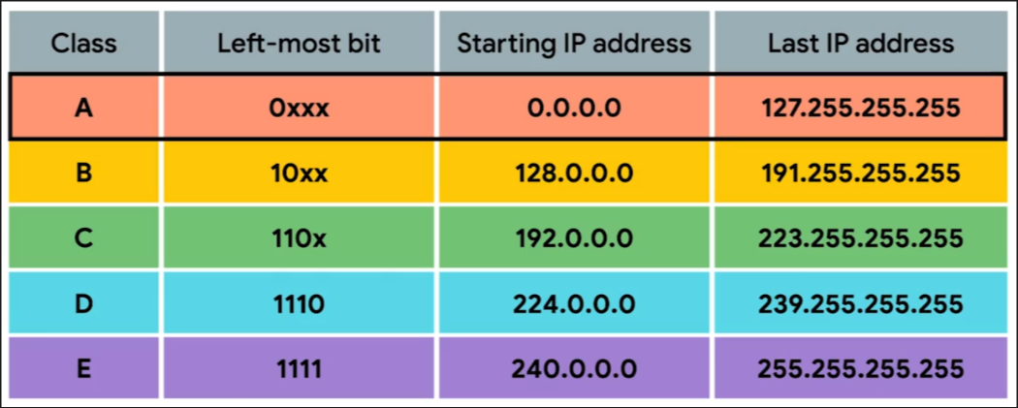

Additional Classes
- Class D (Multicast):
  - First bits: 1110
  - First octet: 224–239
  - Used for sending data to multiple hosts at once.
- Class E (Reserved/Experimental):
  - First bits: 1111
  - First octet: 240–255
  - Not assigned for public use; testing only.

Key Points
- Class A: Large networks (e.g., IBM owns 9.x.x.x).
- Class B: Medium-sized networks.
- Class C: Small networks.
- Modern Replacement: CIDR (Classless Inter-Domain Routing) is now more common, but classful addressing is still foundational.

Quick Identification
- 0–127 → Class A
- 128–191 → Class B
- 192–223 → Class C
- 224–239 → Class D (Multicast)
- 240–255 → Class E (Reserved)

